Challenge Number: 1002
Played on date: February 16, 2020 Time: 13:00
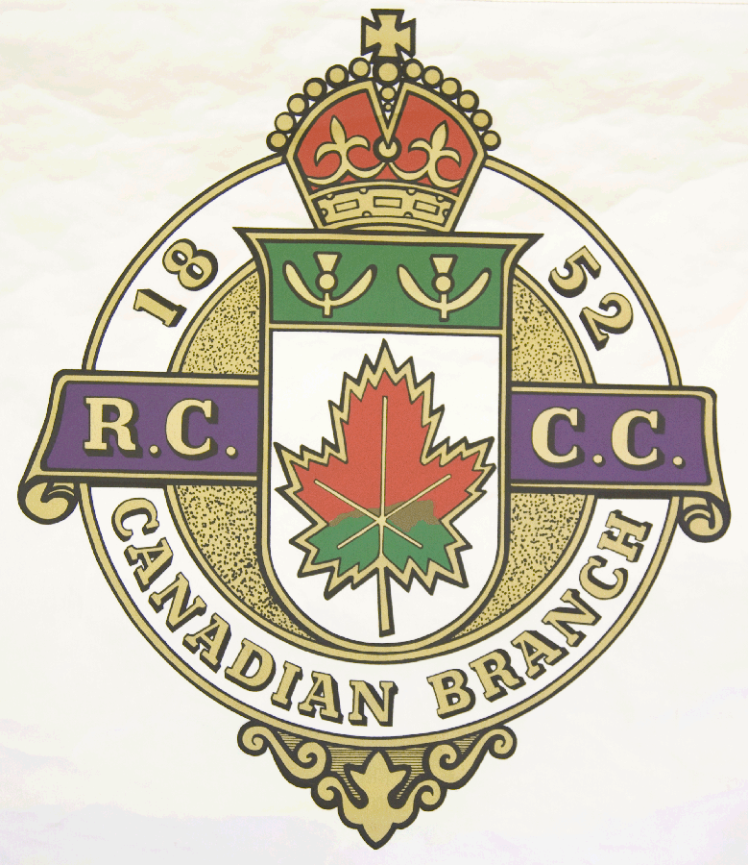
Hosting Club: Metcalfe Curling Club

Host Club Address: 2793 8th Line Road

Host Club City: Metcalfe, Ontario

Host Club Telephone: 613 - 821 - 2335

Host Contact Person: Bill Woods Sr.

Contact phone or email: bill.woods@sympatico.ca

Hosting Club: Metcalfe Challenging Club: Huntington

Skip: Bill Woods Sr. Skip: Fred Hutchings

Third: Dave Kemp Third: Randy McLean

Second: Brent Denison Second: Karl Aspelund

Lead: Terry Lantz Lead: Gary Ouimet

Skip: Billy Woods Jr. Skip: John Soesbergen

Third: Don Chasse Third: Clo Mueller

Second: Bill Carr Second: Markus Mueller

Lead: Niall MacLean Lead: John Cluff .

 | Skip | 1 | 2 | 3 | 4 | 5 | 6 | 7 | 8 | 9 | 10 | Score
Sheet | Woods Sr. |  | 1 |  | 3 | 1 |  | 1 | x | x | x | 6
Sheet | Hutchings | 1 |  | 1 |  |  | 1 |  | x | x | x | 3
Sheet | Woods Jr. | 2 | 3 |  | 5 |  | 2 |  | x | x | x | 12
Sheet | Soesbergen |  |  | 1 |  | 1 |  | 1 | x | x | x | 3

Hosting club score: 18____ Challenging club score: __ 6____

A hard fought game with great comradery. Photo on next page.

